Modeling, Simulating, and Analyzing 2D IR-Raman and 2D electronic-vibrational Spectroscopies

Yoshitaka Tanimura
Department of Chemistry, Kyoto University, Kyoto 606-8502, Japan
http://theochem.kuchem.kyoto-u.ac.jp

Understanding dynamics in complex environments of molecular liquids and biological systems has been a central topic of investigation in chemistry and biology, because many important chemical processes occur exclusively in such media. The key feature of this system is that it describes irreversible dynamics refers to open quantum dynamics through which the primary system evolves toward the thermal equilibrium state at finite temperature. Our group have been working on this problem on the basis of the reduced equations of motion approach. In this talk, I overview our latest results for the following three topics.

1) 2D IR-Raman spectroscopy for liquid water [1].
2) Machine learning approach for modeling liquids water [2]
2) 2D electronic vibrational spectroscopies (2DEVS) for non-adiabatic transition system[3-5]

References (PDF: http://theochem.kuchem.kyoto-u.ac.jp/public/)
[1] H. Ito and Y. Tanimura, Simulating 2D IR-Raman and Raman spectroscopies for inter-molecular and intramolecular modes of liquid water, J.Chem.Phys.144, 074201 (2016).(pdf)
[2] S. Ueno and Y. Tanimura, Modeling intermolecular and intramolecular modes of liquid water with using multiple heat baths: Data-mining approach, in preparation.
[3] T. Ikeda and Y. Tanimura, Probing photo isomerization processes by means of multi-dimensional electronic spectroscopy: The multi-state quantum hierarchal Fokker-Planck Equation approach, J. Chem. Phys. 146, 014102 (2017).(pdf)
[4] T.Ikeda and Y.Tanimura, Phase-space wavepacket dynamics of internal conversion via conical intersection: Multi-state q. Fokker-Planck eq. approach, Chem. Phys. 515, 203 (2018). (pdf)
[5] T. Ikeda and Y. Tanimura, Low-Temperature Q. Fokker-Planck and Smoluchowski Equations and Their Extension to Multistate Systems, J. Chem.Theo. Comp.15 2517 (2019). (pdf)
[6] T. Ikeda, Y. Tanimura and A. Dijkstra, Modeling and analyzing a photo-driven molecular motor system: Ratchet dynamics and non-linear optical spectra, J. Chem. Phys. 150, 114103 (2019). (pdf)

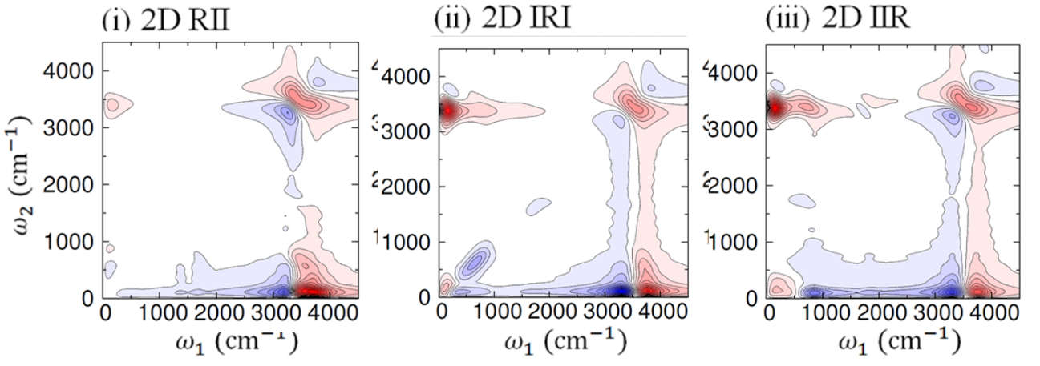
2D IR-Raman spectra of liquid water calculated from full MD simulations for (i) 2D Raman-IR-IR, (ii) 2D IR-Raman-IR and (iii) 2D IR-IR-Raman spectroscopies. (Ref. [1])

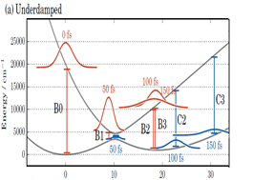
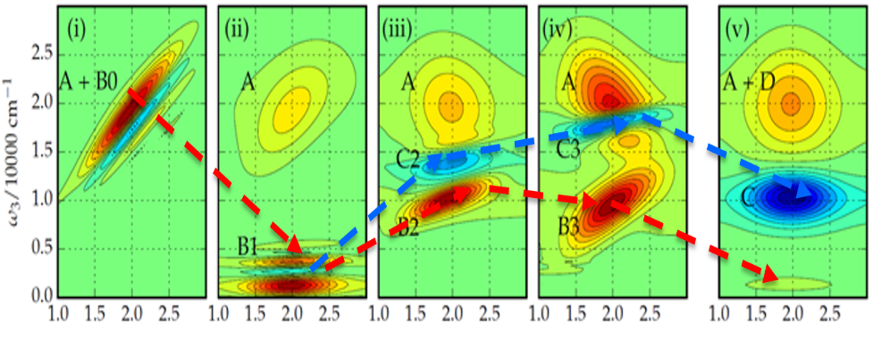
2D EVS for non-adiabatic dynamics (Ref .3)
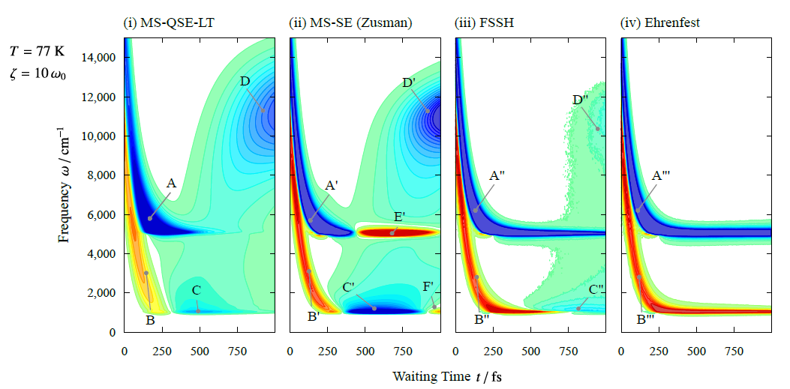
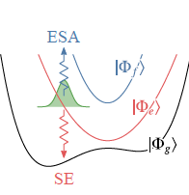

Transient absorption spectra of a three-state system (right figure) for an overdamped case obtained from the (i) multi-state quantum Smoluchowski Eq. (MS-QSE-LT) (ii) multi-state classical Smoluchowski Eq. (MS-SE) or Zusman Eq., (iii) fewest switch surface hopping (FSSH) methods, and (iv) Ehrenfest methods, respectively. (Ref. [5])

