Matthias Beller
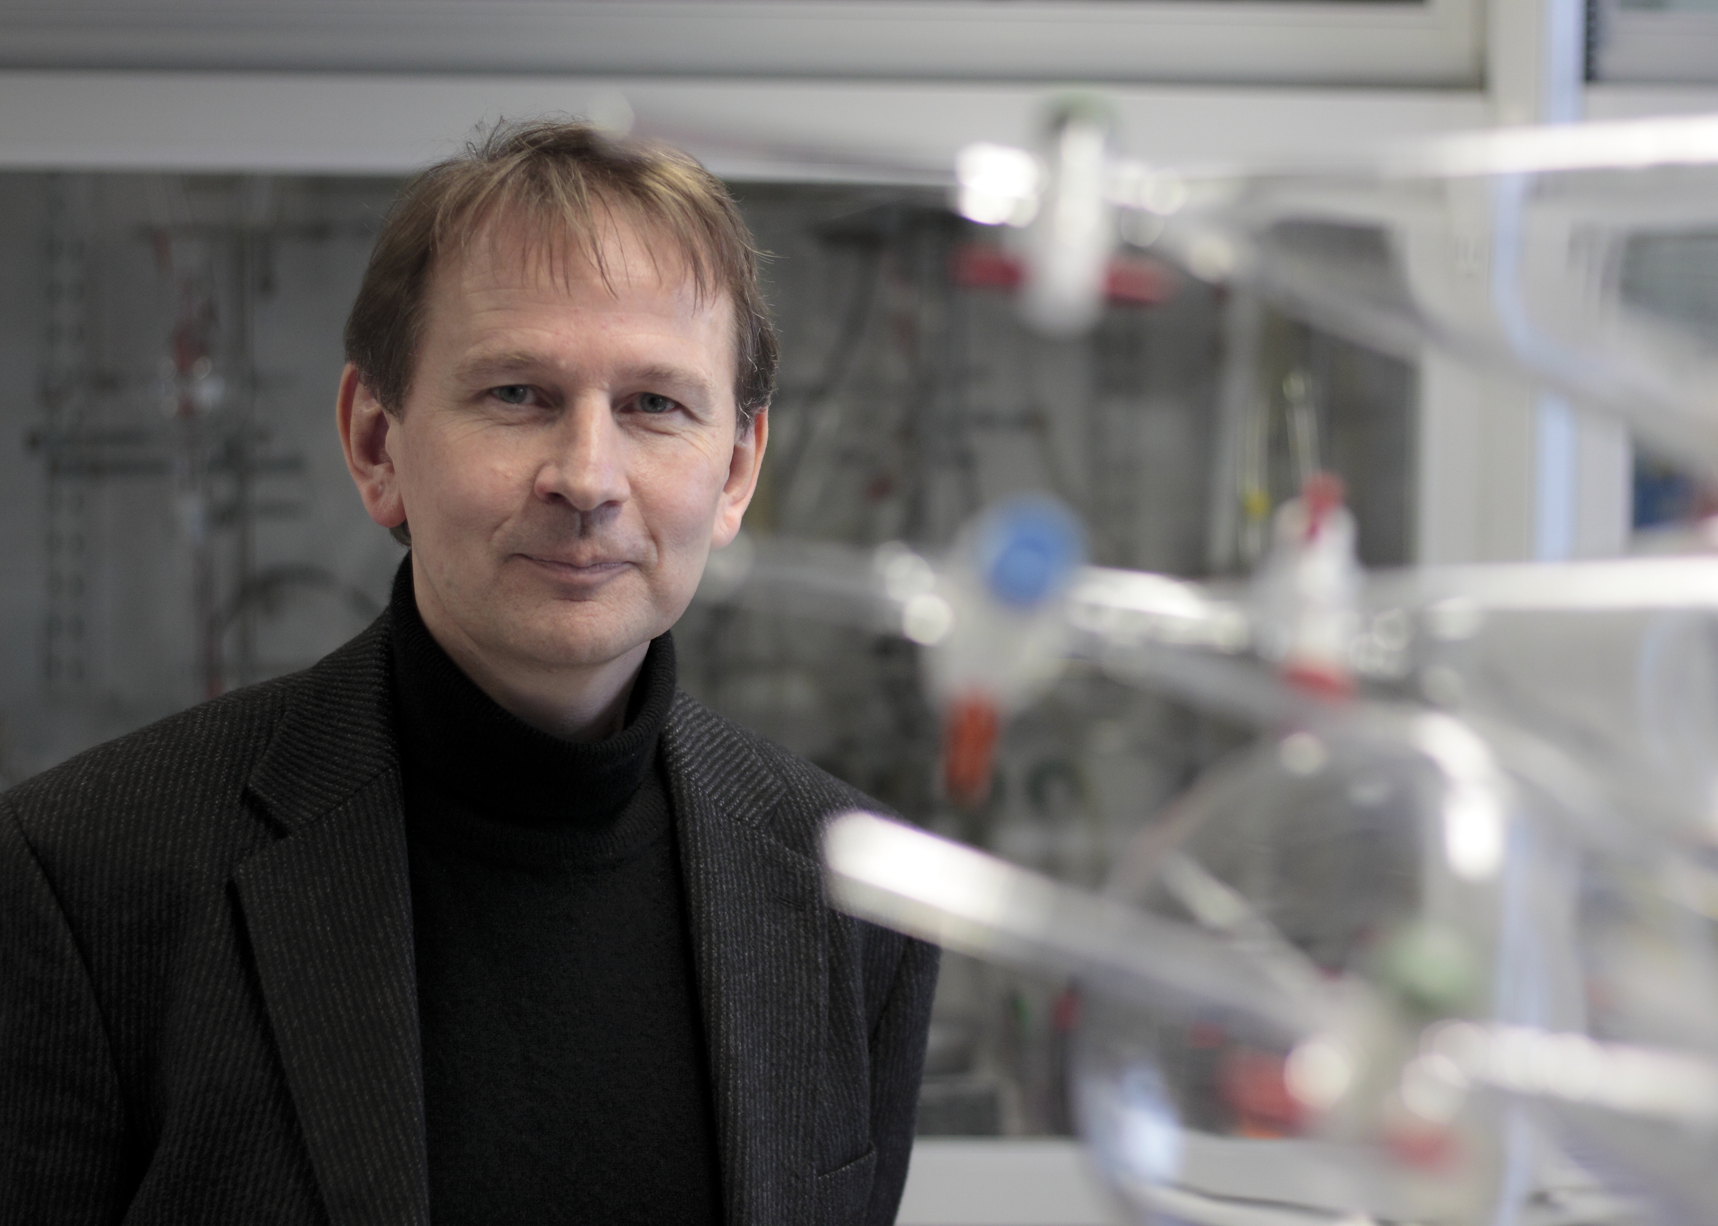
Professor of Catalysis
Leibniz-Institut für Katalyse an der Universität Rostock
Address: Albert-Einstein-Str. 29a, 18059 Rostock, Germany
Tel: (+49)-381-12810
E-mail: matthias.beller@catalysis.de

Scientific Vita and Awards and Recognition
Matthias Beller, born 1962 in Gudensberg, studied chemistry at the University of Göttingen, Germany, where he completed his PhD thesis in 1989 in the group of L.-F. Tietze. As recipient of a Liebig scholarship, he then spent a one-year with K. B. Sharpless at MIT, USA. From 1991 to 1995, Beller worked in industry. Then, he moved to the Technical University of München as Professor for Inorganic Chemistry. In 1998, he relocated to Rostock to head the Institute for Organic Catalysis, which became in 2006 the Leibniz-Institute for Catalysis. The work of his group has published in more than 750 publications and the current research mainly focuses on 1) non-noble metal-catalyzed oxidations and hydrogenations 2) CO and carbon dioxide valorization, e.g. hydroformylations 3) fine chemical synthesis (Pd- and Cu-catalyzed cross-coupling reactions) and 4) homogeneous and heterogeneous catalysis for energy technologies (hydrogen generation and storage). He has received several awards including the Otto-Roelen Medal and the Leibniz-Price of the DFG. In 2006, he was also awarded “Entrepreneur of the Year” of Rostock and he received the German Federal Cross of Merit. Since then, he received the first “European price for Sustainable Chemistry”, the “Paul-Rylander Award” of the Organic Reaction Catalysis Society of the USA, the Gay-Lussac-Alexander-von-Humboldt-Prize of the French Academy of Sciences and the Emil Fischer Medal of the German Chemical Society. More recently in 2015, he was awarded honorary doctoral degrees from the University of Antwerp, Belgium and the University of Rennes, France. In addition, he received the Wöhler Price for Sustainable Chemistry from the German Chemical Society. Matthias Beller is also Vice President of the Leibniz Society – one of the major science organizations in Germany and a member of the German National Academia of Science “Leopoldina” and three other Science Academies. He is married to Dr. Anja Fischer-Beller and they have two sons.

Selected Publications
[1] F. Westerhaus, R. Jagadeesh, G. Wienhöfer, M.-M. Pohl, J. Radnik, A.-E. Surkus, K. Junge, H. Junge, M. Beller, Nature Chem. 2013, 5, 607-612.
[2] M. Nielsen, E. Alberico, W. Baumann, H.-J. Drexler, H. Junge, S. Gladiali, M. Beller, Nature 2013, 494, 85-89.
[3] A. Boddien, D. Mellmann, F. Gärtner, R. Jackstell, H. Junge, P. J. Dyson, G. Laurenczy, R. Ludwig, M. Beller, Science 2011, 333, 1733-1736.
[4] R. V. Jagadeesh, A.-E. Surkus, H. Junge, M.-M. Pohl, J. Radnik, J. Rabeah, H. Huan, V. Schünemann, A. Brückner, M. Beller, Science 2013, 342, 1073-1076; Nanoscale Fe₂O₃–Based Catalysts for Selective Hydrogenation of Nitroarenes to Anilines.
[5] L. Wu, Q. Liu, I. Fleischer, R. Jackstell, M. Beller, Nature Commun. 2014, 5; 4091/1-4091/6; Ruthenium-catalysed alkoxycarbonylation of alkenes with carbon dioxide.

Sustainable Chemistry with Homogeneous and Heterogeneous Catalysts: What are the Differences?

Matthias Beller
Leibniz-Institut für Katalyse an der Universität Rostock, Albert-Einstein-Str. 29a, 18059 Rostock, Germany
matthias.beller@catalysis.de

Abstract:
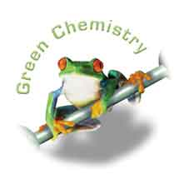
Despite numerous important methodological advancements in all areas of chemistry, still most organic synthesis as well as the industrial production of chemicals can be improved. Currently, more than 80% of all products of the chemical industry are made via catalysis. In this regard, the development of new and more efficient catalysts constitutes a key factor for achieving a sustainable production of all kinds of chemicals today and in the future. Here, several major challenges will be presented in the talk; e.g. the selective reduction of amides to bio-relevant amines. Furthermore, it will be shown that recently developed molecular-defined as well as nano-structured cobalt and iron catalysts enable us to perform catalytic hydrogenation processes of esters and nitro derivatives with high yields and unprecedented selectivity. Specific examples which demonstrate the potential of catalytic processes with bio-relevant metal complexes compared to more traditional catalytic reactions will include apart from hydrogenations also dehydrogenations for the synthesis of heterocycles. In the future, also for industrial processes improved economics based on the presented novel catalysts might be expected.

