On-surface synthesis by atomic manipulation studied with atomic force microscopy

Leo Gross

IBM Research – Zurich, 8803 Rüschlikon, Switzerland

Elusive molecules can be created using atomic manipulation with a combined atomic force/scanning tunneling microscope (AFM/STM). Molecules that are highly reactive and short-lived under ambient conditions can be stabilized at low temperature and by using inert surfaces. Employing high-resolution AFM with CO functionalized tips [1] provides insights into the structure, geometry, aromaticity and bond orders of the molecules created and into the reactions performed [2]. STM is used to map orbital densities and obtain information about the occupation of orbitals and transport gaps.

We created radicals, diradicals [3], antiaromatic and non-Kekulé molecules [4] and studied their structural and electronic properties. We recently showed that the reorganization energy of a molecule on an insulator can be determined [5]. In addition, we expanded the toolbox for the synthesis of molecules by atomic manipulation, demonstrating reversible cyclisation reactions [3] (see Figure) and skeletal rearrangements.
.
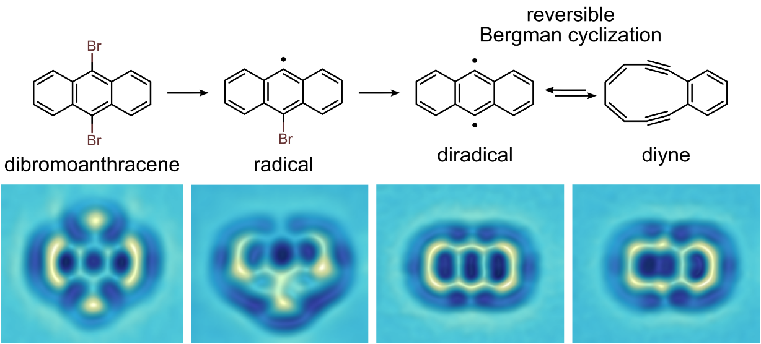

Figure: Reversible Bergman cyclization by atom manipulation: Chemical reaction scheme (top). CO-tip AFM data (bottom), showing the different reaction steps an individual molecule on bilayer NaCl on Cu(111) . All reaction steps are induced by bias voltage pulses with the AFM tip. [3]

References:
[1] L. Gross et al. Science 325, 1110 (2009)
[2] L. Gross et al. Angew. Chem Int. Ed. DOI: 10.1002/anie.201703509 (2018)
[3] B. Schuler et al. Nat. Chem. 8, 220 (2016)
[4] N. Pavliček et al. Nat. Nano. 12, 308 (2017)
[5] S. Fatayer et al. Nat. Nano. accepted (2018)

