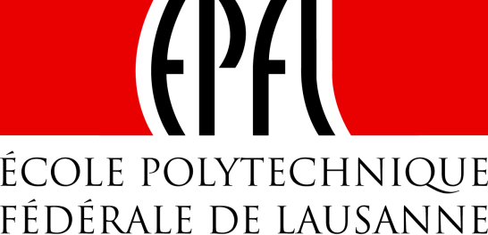 | 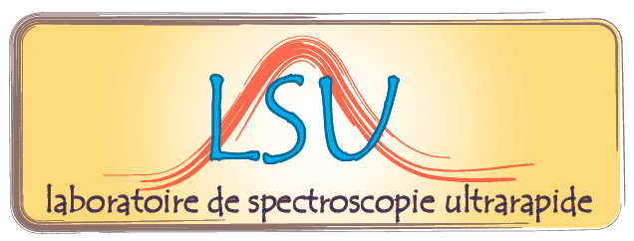

Institut des Sciences et Ingénieries Chimiques (ISIC)

Séminaire/Seminar

Nonlinear Silicon Photonic devices

Dr. Cosimo Lacava
University of Pavia, Quantum Electronics Laboratory

Silicon photonics is a well-established platform for the development of fully integrated devices for optical communications system. The high index difference achievable in the SOI (silicon-on-insulator) platform allows the realization of miniaturized waveguide structures (typical width 500 nm) with high beam confinement and very low curvature losses. Due to the reduced mode area and to the strong nonlinear refractive index of bulk silicon, ultra high nonlinear effects can be easily achieved in these structures using power levels usually adopted in telecommunication systems. Future high capacity networks will require high speed devices that can perform all-optical signal processing functionalities. However, strong nonlinear absorption is also present, at moderate power levels, in such devices. These effects strongly limit the overall performance of non-linear silicon devices; therefore a different approach is needed. I will discuss several techniques that can reduce nonlinear absorption that also include: a) amorphous silicon hydrogenated waveguides, b) slot-based waveguides filled by silicon nanocrystals.

Mardi 20 mai 2014 à 14 heures en salle CH G1 495
Thuesday, 20 May 2014, at 14 PM in room CH G1 495
___________________________________________________________________________

Contact : Prof. M. Chergui (30457)

