**Michael Graetzel**

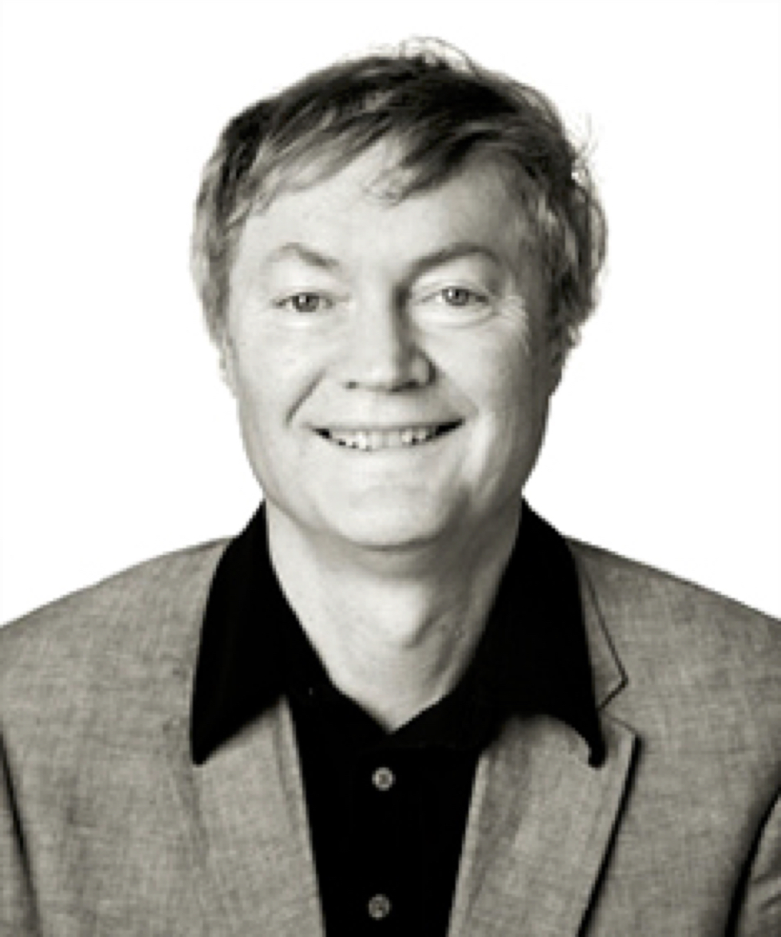

Professor of Physical Chemistry at the Ecole Polytechnique Fédérale de Lausanne, he directs there the Laboratory of Photonics and Interfaces. He pioneered research in the field of energy and electron transfer reactions in mesoscopic systems and their use for the generation of electricity and fuels from sunlight as well as the storage of electric power in lithium ion batteries. Author of several books and some 1200 publications that received some 180’000 citations and with an ISI h-factor of 195 he is one of the 3 most highly cited chemists in the world. His recent awards include the Paracelsus Prize of the Swiss Chemical Society, the KingFeisal International Science Prize, the Samson Prime Minister’s Prize for Innovation in Alternative Fuels*,* theFirst Leigh-Ann Conn Prize in Renewable Energy, the Albert Einstein World Award of Science, the Marcel Benoist Prize, the Paul Karrer Gold Medal, the Gutenberg Research Award*,* the Millennium Technology Grand Prize, and the Balzan Prize. He graduated as Doctor of natural science from the Technical University of Berlin and received 10 honorary doctors degrees from Asian and European Universities. He is a member of theSwiss Chemical Society and an elected member of the German Academy of Science (Leopoldina)as well as Honorary member of the Israeli Chemical Society, the Bulgarian Academy of Science and the Société Vaudoise de Sciences Naturelles. Recently he was named Fellow of the Max Planck Society and Honorary Fellow of the Royal Society of Chemistry (UK).