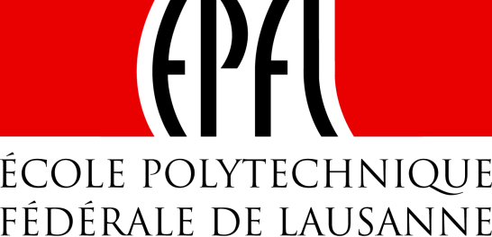 | 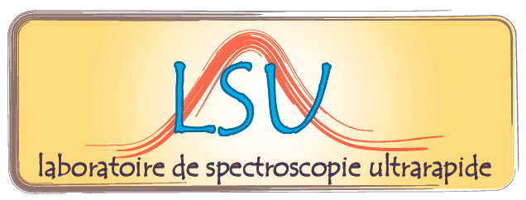

Institut des Sciences et Ingénieries Chimiques (ISIC)

Séminaire/Seminar

Time resolved spectroscopy of the Liquid-Glass transition Molecular Liquids and LiCl-water Solutions

Robert Pick, professor emeritus

Institute of Mineralogy, Materials Physics and Cosmochemistry

The Liquid-Glass transition is a continuous process during which different (macroscopic) relaxation times of the liquid change from the ps to the hours when decreasing the temperature by, typically, 100 K. Time Resolved Spectroscopy in the ns-ms range allows to study a particularly important region of this transition during which the dynamics changes from a normal-liquid type to a more “glassy” one.

I shall present results for:

- A molecular liquid, metatoluidine, for which we have shown that different relaxation times have not the same temperature variation ;
- LiCl-RH₂O mixtures, in which the R=6 solution presents already some unusual features with respect to the classical vitrification scheme, a new and more surprising effect appearing for the 6<R<7.2 solutions.

Mardi 1er avril 2014 à 11 heures, en salle CH G1 495
Tuesday, 1 April 2014, at 11 AM in room CH G1 495
___________________________________________________________________________

Contact : Prof. M. Chergui (30457)

