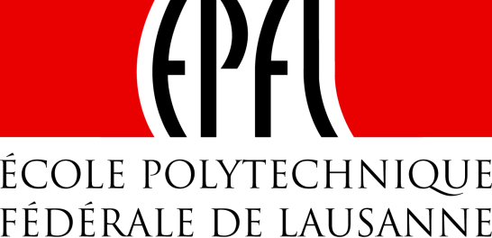 | 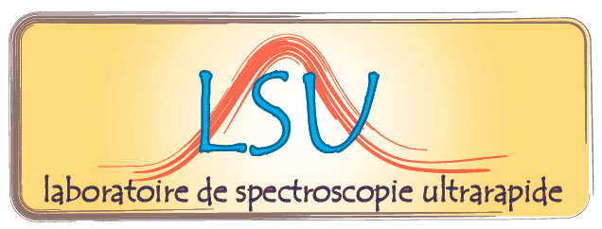

Institut des Sciences et Ingénieries Chimiques (ISIC)

Séminaire/Seminar

Ultrafast Electron Microscopy:
a New Tool to Study Chemical Dynamics at the Nanoscale

Renske Van der Veen
Max Planck Institute for Biophysical Chemistry, Göttigen, Germany

Ultrafast electron microscopy (UEM) combines the high time resolution of conventional optical spectroscopy with the excellent spatial resolution of electron microscopy techniques. The structural and electronic changes are initiated by short (fs, ps, ns) laser pulses, which are followed by similarly short electron pulses for probing the dynamics by means of imaging, diffraction, or energy-loss spectroscopy (EELS). The inherent spatial resolution and imaging capabilities of transmission electron microscopy are ideal to pinpoint individual nanostructures and to investigate size effects and the influence of the surroundings. In this seminar, I will present our results on the switching of spin-crossover nanoparticles, demonstrating for the first time the unique sensitivity of UEM for the in situ visualization of single-nanoparticle dynamics. In addition, I will discuss the potentials of time-resolved core-EELS experiments as an alternative to soft-X-ray spectroscopy.

Vendredi 4 avril 2014 à 10 heures 30, en salle CH G1 495
Friday, 4 April 2014, at 10:30 AM in room CH G1 495
___________________________________________________________________________

Contact : Prof. M. Chergui (30457)

