ENERGYPOLIS SEMINAR
9. 8. 2016, 11:00 - 12:00, ENERGYPOLIS Sion, 4th floor, Seminar room

Simulation of wet milling of active pharmaceutical ingredients by a population balance model
Vladimir Gorbachev
Next Generation Scientist 2017, NOP Proj. Integrat. & Part. Eng., Technical Research & Development, Global Drug Discovery, Novartis Pharma AG, Basel, Switzerland
The shape, size distribution and surface properties of active pharmaceutical ingredient (API) particles are critical quality attributes which can affect not only the API’s process ability, but also the dissolution kinetics of the resulting formulated drug. Although wet milling is successfully applied in the chemical and pharmaceutical industry for many years to modify particle shape and the size distribution,¹ the milling processes are mostly developed empirically by trial and error. A better understanding of the effect of specific milling operations on particle properties would benefit process development in the pharmaceutical industry.^{2,3}
The objective of this work is to develop and implement a population balance model to describe the particle breakage in a conical rotor-/stator wet mill. A variety of breakage mechanisms compete concurrently and particles can additionally partially dissolve during milling depending on the energy input, particle size and solubility. Particle Size Distribution is also determined and validated with literature data. As part of this work, the dominant effects was identified and was included in the model. The resulting population balance model facilitate the scale-up of wet milling processes from lab to pilot plant.
Moreover, significant part of work is devoted to CFD-simulation and opportunity the scale-up of crystallization process from lab to pilot plan and determination of influence of basic input parameters like: type of crystallization, impellers type, mode of mixing etc.
References:
[1] Stadler, R, Polke R, Schwedes J., Vock F., Chem-Ing-Tech 62 (1990) 907-915.
[2] Luciani C.V., Conder E.W., Seibert K.D., Org. Process Res. Dev. 19 (2015) 582-589.
[3] Juhnke M., John E., Chem. Eng. Technol. 37 (2014) 757-764.
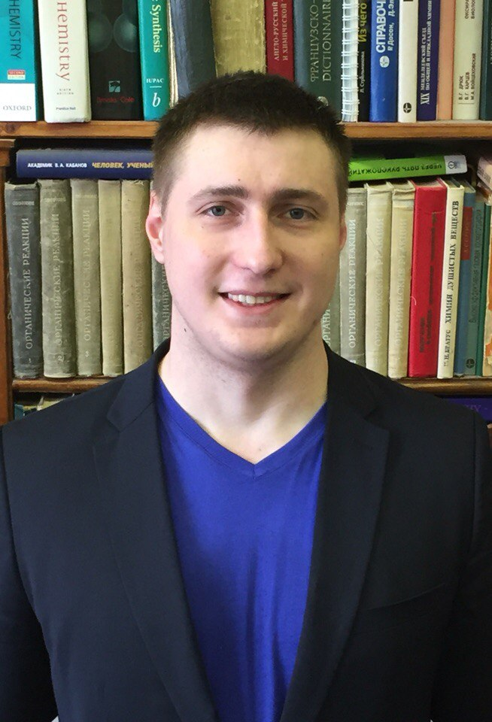 | CV: M.Sc. Vladimir Gorbachev  Born in 1991 in Kishinev, USSR. Vladimir Gorbachev graduated Volgograd State Technical University (VSTU) with a «Chemical Engineering and Biotechnology» (BSc), and «Chemistry and technology of basic organic and petrochemical synthesis products» (MSc) in 2012, and in 2014 respectively. Since Oct 2015 until May 2017 worked as Engineer in Lomonosov Moscow State University. His scientific research project is synthesis 4,4-dichlorine-1,2-diazabutadienes-1,3 and 2-H-1,2,3-triazoles. Now he is participating at Next Generation Scientists-2017 by Novartis Pharma AG in Basel, Switzerland.

