Seminar Title:

Total Synthesis for Better/New Function

Biosketch:
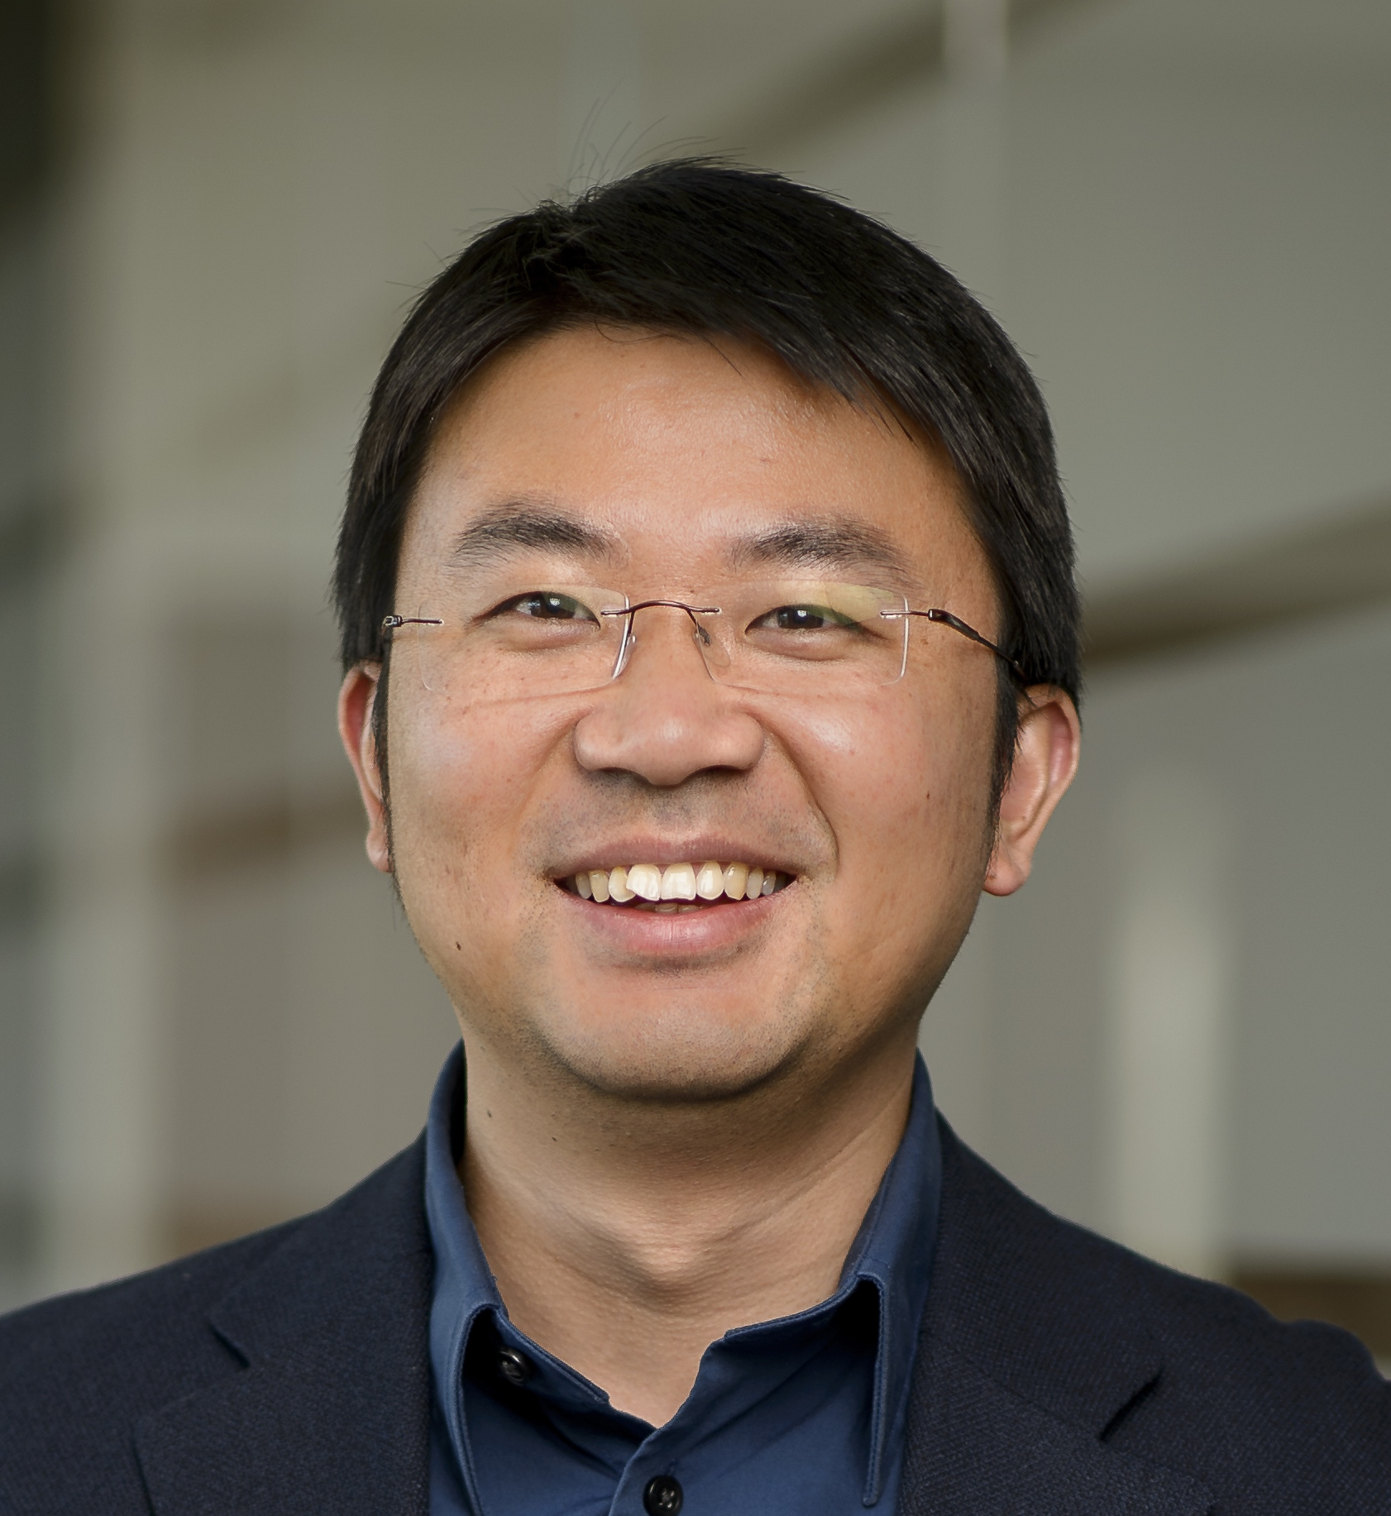

Mingji Dai received his B.S. degree from Peking University in 2002. After two years’ research with Professors Zhen Yang and Jiahua Chen in the same university, he went to New York in 2004 and pursued graduate study under the guidance of Professor Samuel J. Danishefsky at Columbia University. After earning his Ph.D. degree in 2009, he took a postdoctoral position in the laboratory of Professor Stuart L. Schreiber at Harvard University and the Broad Institute. In the August of 2012, he began his independent career as an assistant professor in the Chemistry Department and Center for Cancer Research of Purdue University and was promoted to associate professor in 2018. His lab currently focuses on developing new strategies and methodologies for the synthesis of complex natural products and other medicinally important molecules. His recent awards include the Amgen Young Investigators’ Award, the Eli Lilly Grantee Award, the 2017 Chinese-American Chemistry & Chemical Biology Professors Association (CAPA) Distinguished Junior Faculty Award, the NSF CAREER Award, the 2015 Organic Letters Outstanding Author of the Year Lectureship Award, and the 2015 Thieme Chemistry Journal Award.

