EIDGENÖSSISCHE TECHNISCHE HOCHSCHULE LAUSANNE
POLITECNICO FEDERALE DI LOSANNA
SWISS FEDERAL INSTITUTE OF TECHNOLOGY LAUSANNE
Prof. Suliana Manley
Laboratory of Experimental Biophysics
Institute of Physics of Biological Systems
BSP 427/Cubotron
CH-1015 Lausanne, Suisse
Tél (+41) 21 693 06.32

Fax (+41) 21 693 04 22
suliana.manley@epfl.ch
http://leb.epfl.ch/

It is our pleasure to invite you to the following seminar:

Wednesday May 29th, 2019 at 13:45-14:15
BSP 231, Cubotron/Unil, 2nd floor
(Bâtiment sciences physiques UNIL)

Unveiling the dynamic nature of cellular nanopores in living endothelial cells by video-rate super-resolution microscopy

by
- Prof. Thomas Huser
- Biomolecular Photonics, Department of Physics, University of Bielefeld, Bielefeld, Germany

Super-resolved structured illumination microscopy (SR-SIM) is among the most flexible, fastest and least perturbing fluorescence microscopy techniques capable of surpassing the optical diffraction limit. Current custom-built instruments are easily able to deliver two-fold resolution enhancement at video-rate frame rates, but the cost of the instruments is still relatively high and the physical size of the instruments is still prohibitively large. Here, I will present our latest efforts towards realizing a new generation of compact, cost-efficient and high-speed SR-SIM instruments. Tight integration of the structured illumination microscope capable of video-rate image acquisition with instant image reconstruction enables us to realize a super-resolving fluorescence microscope with the look-and-feel of regular wide-field microscopy. I will demonstrate this by presenting dynamics of intracellular transport and movement in living cells, in particular the dynamics of liver cell fenestrations. These nano-sized pores in liver endothelial cells play a particularly crucial role in human physiology, which is reduced or lost during disease and/or aging. To best address these issues from all perspectives, we utilize a suite of multimodal methods, e.g. the combination of optical tweezers with optical nanoscopy, or the combination of temporal and spatial methods of improving the spatial resolution and select the best possible method for each research question. I will present the pros and cons of these methods, their combination, and their applications on select biomedical examples.

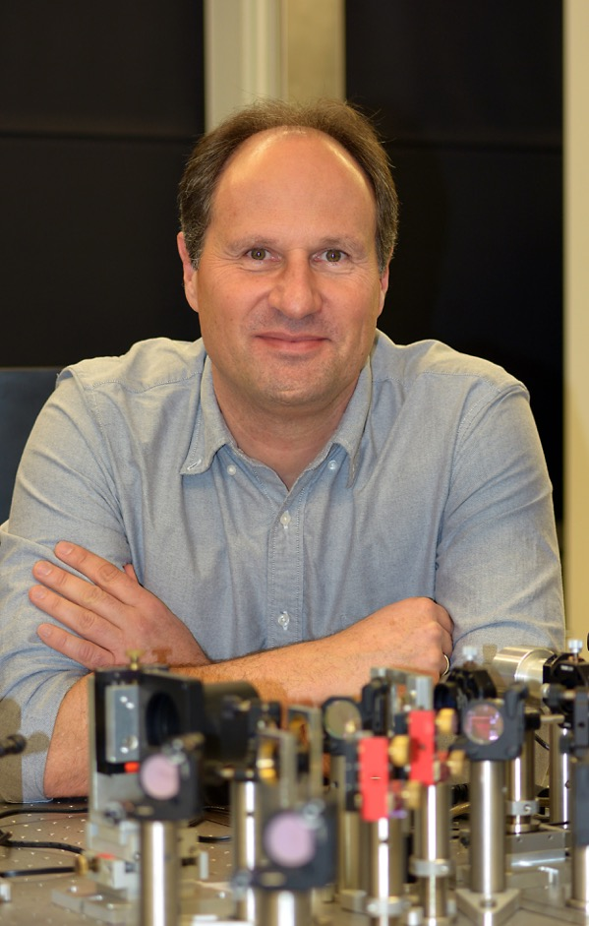 | Thomas Huser is a Professor of Physics at the University of Bielefeld, Germany. He holds several patents on single molecule and single cell analysis techniques, and has over 120 peer-reviewed publications. Until 2011 he served as Chief Scientist for the NSF Center for Biophotonics Science and Technology at the University of California, Davis. Until November 2005, Dr. Huser was a Group leader for Biophotonics and Nanospectroscopy at Lawrence Livermore National Laboratory in Livermore, CA, where he developed and applied novel nano-biophotonics tools to the analysis and characterization of individual cells. Dr. Huser obtained his Ph.D. in Physics from the University of Basel, Switzerland, where he worked primarily on near-field optical microscopy. At the University of Bielefeld he applies optical nanoscopy and spectroscopy techniques to biological and medical problems at the single cell level. https://www.physik.uni-bielefeld.de/biopho/index.php/en/

