Masahiro Terada  Affiliation: Department of Chemistry, Tohoku University  Address: Aramaki, Aoba-ku, Sendai 980-8578, JAPAN  Email: mterada@m.tohoku.ac.jp  Website: http://www.orgreact.sakura.ne.jp/en-index.html | 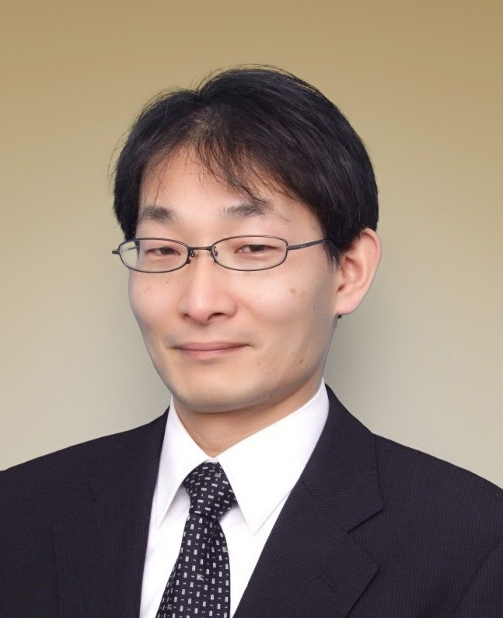

Title of Talk: Enantioselective Catalysis by Chiral Brønsted Acids and Bases

Professor Masahiro Terada was born in Tokyo in 1964. He was graduated from Department of Applied Chemistry, Tokyo Institute of Technology in 1986 and completed his Ph.D. degree in 1993 from Tokyo Institute of Technology under the direction of Professor Koichi Mikami. During his Ph.D. study, he was appointed as an assistant professor in Professor Mikami’s Laboratory at Tokyo Institute of Technology (1989-2001). He worked as a postdoctoral fellow with Professor M. D. Shair at Harvard University in 1999-2000 and moved to Tohoku University as an associate professor in 2001. He has been a Professor of Chemistry at the Graduate School of Science, Tohoku University (Japan) since 2006.
He is the recipient of: The Incentive Award in Synthetic Organic Chemistry, Japan (2003), The Chemical Society of Japan Award for Creative Work (2008)
Mukaiyama Award (2010), Daiichi-Sankyo Award for Medicinal Organic Chemistry (2011), The Nagoya Silver Medal (2012), Molecular Chirality Award 2015 (2015).
He is an Associate Editor of Organic Chemistry Frontiers, one of RSC Journals for organic chemisrty research filed, and Chair of Committees for Research Promotion in Specialized Areas “Advanced Molecular Transformations by Organocatalysts”. His current research interests are focused on the development of new and useful synthetic methodologies based on the design of novel chiral Brønsted acid and base catalysts as well as the utilization of transition metal catalysts.

Selected Recent Publications
(1) “Enantioselective Aza Michael-type Addition to Alkenyl Benzimidazoles Catalyzed by Chiral Phosphoric Acid”, Y.-Y. Wang, K. Kanomata, T. Korenaga, M. Terada Angew. Chem. Int. Ed. 2016, 55, 927-931.
(2) “Chiral Brønsted Acid-Catalyzed Enantioselective Friedel-Crafts Reaction of 2-Methoxyfuran with Aliphatic Ketimines Generated in Situ”, A. Kondoh, Y. Ota, T. Komuro, F. Egawa, K. Kanomata, M. Terada Chem. Sci. 2016, 7, 1057-1062.
(3) “Enantioselective Addition of a 2-Alkoxycarbonyl-1,3-dithiane to Imines Catalyzed by a Bis(guanidino)iminophosphorane Organosuperbase”, A. Kondoh, M. Oishi, T. Takeda, M. Terada Angew. Chem. Int. Ed. 2015, 54, 15836-15839.
(4) “Ring Expansion of Epoxides under Brønsted Base Catalysis: Formal [3+2] Cycloaddition of β,γ-Epoxy Esters with Imines Providing 2,4,5-Trisubstituted 1,3-Oxazolidines”, A. Kondoh, K. Odaira, M. Terada Angew. Chem. Int. Ed. 2015, 54, 11240-11244.
(5) “Skeletal Rearrangement of O-Propargylic Formaldoximes by a Gold-Catalyzed Cyclization/Intermolecular Methylene Transfer Sequence”, I. Nakamura, S. Gima, Y. Kudo, M. Terada Angew. Chem. Int. Ed. 2015, 54, 7154-7157.
(6) “Kinetic Resolution of Racemic Amino Alcohols through Intermolecular Acetalization Catalyzed by Chiral Brønsted Acid” T. Yamanaka , A. Kondoh , M. Terada J. Am. Chem. Soc. 2015, 137, 1048-1051.

